Pizza sales report query

1.total revenue

--Find out Total revenue---

select sum(total_price) as Total_Revenue from pizza_sales

2.Average order values---

---Total average values---

select sum(total_price)/count(distinct order_id) as Avg_ordervalue from pizza_sales

3.total pizza sold---

---total pizza sold---

select sum(quantity) as Total_sales from pizza_sales--49574

4.total order---

--total order placed---

select count(distinct order_id) as Total_orders from pizza_Sales—21350

5.Average pizzas per order---

-- average pizzas per order---

select sum(quantity)/count(distinct order_id) from pizza_sales---2

note:---we want in exact decimal form

-- average pizzas per order---

select cast(sum(quantity) as **decimal(10,2))/**CAST(count(distinct order_id) AS **DECIMAL(10,2**)) from pizza_sales.

DECIMAL(10,2) MEANS RESULT WILL BE IN 10 DECIMAL PLACES AND OUT OF THAT ONLY 2 DECIMAL PLACES WILL BE SELECTED.

**----------------CHARTS REQUIREMENTS---------**

DAILY TRENDS FOR OUR TOTAL ORDER

SELECT DATENAME(DW,order_date) as order_day,count(distinct order_id) as total_orders

from pizza_sales

group by DATENAME(DW,order_date)

MONTHLY TRENDS FOR OUR TOTAL ORDERS

SELECT DATENAME(month,order_date) as order_month,COUNT(DISTINCT ORDER_ID) from pizza_sales

group by DATENAME(MONTH,ORDER_DATE)

ORDER BY COUNT(DISTINCT ORDER_ID) desc

----percentage of sales by pizza category---

select pizza_category,sum(total_price) as total_sales,sum(total_price)*100/(select sum(total_price) from pizza_Sales) as pct_sales

from pizza_sales

group by pizza_category

note:We need to find category based total sales and them divide it by total sales of pizza irrespective of pizza category.

(select sum(total_price) from pizza_Sales)= for getting total sales of pizza

----for a particular month---

select pizza_category,sum(total_price) as total_sales,sum(total_price)*100/(select sum(total_price) from pizza_Sales where month(order_date)=1) as pct_sales

from pizza_sales

where month(order_date)=1

group by pizza_category

--for a quarter---

select pizza_category,sum(total_price) as total_sales,sum(total_price)*100/(select sum(total_price) from pizza_Sales where datepart(quarter,order_date)=1) as pct_sales

from pizza_sales

**where datepart(quarter,order_date)=1**

group by pizza_category

note:It is important to add **WHERE** clause inside sub clause as well to get correct and accurate answers

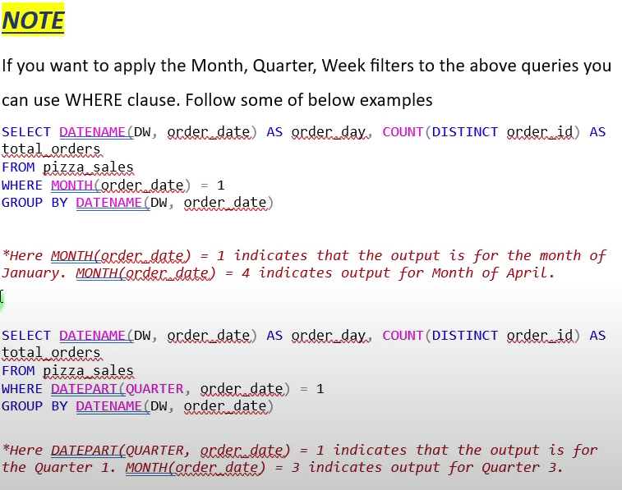

-- percentage of sales by pizza size--

select pizza_size,cast(sum(total_price) as decimal(10,2)) as total_sales,cast(sum(total_price)*100/(select sum(total_price) from pizza_Sales where datepart(quarter,order_date)=1) as decimal(10,2)) as pct_sales

from pizza_sales

where datepart(quarter,order_date)=1

group by pizza_size

order by pct_sales desc

IMPORTANT

-- top 5 best sellers by revenue,total quantity and total orders---

select **top 5** pizza_name,sum(total_price) as total_revenue from pizza_sales

group by pizza_name

order by total_revenue desc

note: for postgre sql use- limit 5

for ms sql use- top 5 after SELECT to get top 5 pizza_name by revenue

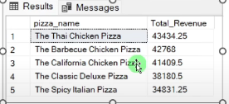

-- bottom 5 BEST SELLING BY total revenue---

select top 5 pizza_name,sum(total_price) as total_revenue from pizza_sales

group by pizza_name

order by total_revenue ASC

-- TOP 5 BEST SELLING BY QUANTITY---

select top 5 pizza_name,sum(quantity) as total_quantity from pizza_sales

group by pizza_name

order by total_quantity desc

-- bottom 5 BEST SELLING BY QUANTITY---

select top 5 pizza_name,sum(quantity) as total_quantity from pizza_sales

group by pizza_name

order by total_quantity asc--- bottom 5

---top 5 best selling pizza by total orders---

select top 5 pizza_name,count(distinct order_id) as total_orders from pizza_sales

group by pizza_name

order by total_orders desc

---bottom 5 best selling pizza by total orders---

select top 5 pizza_name,count(distinct order_id) as total_orders from pizza_sales

group by pizza_name

order by total_orders asc

**DASHBOARD FOR PIZZA_SALES**

* Import data from sql server
* As per client requirements -look for KPI first,clean data,modify data as per requirements.
* Use DAX functions for creating new measures.